Lebanon Reserve
Whoever is the first team playing at Lebanon needs to complete the ground check and submit via the JLT APP

Under 9’s Set Up-
- Cones and goal posts are kept down in back room of clubrooms, you will have access from 7.30. There is enough equipment for 2 games
- Complete ground check via the JLT app, this can be downloaded for free to your phone (picture below).
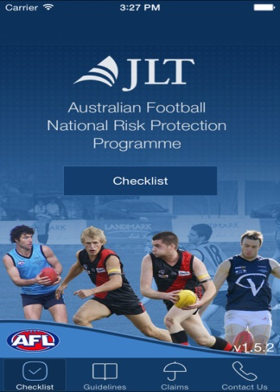
- Important to note that if using permanent goal posts of Lebanon Reserve then goal post padding needs to be up before game can commence
- At the completion of game equipment needs to be removed from the ground asap as EDFL junior games will be commencing immediately
- Ensure all equipment is returned to the back room

Under 11’s set up (if first)
- Complete ground check via the JLT app, this can be downloaded for free to your phone (picture below). Only if you are the first team
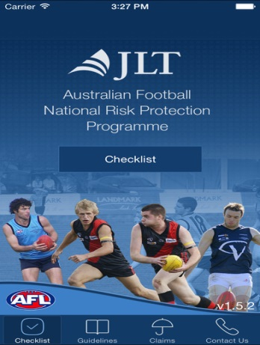
- Goal post padding to go up
- Ensure laptop is set up in timekeepers box via the instructions in the clubrooms
- Ensure Stretcher is in timekeepers box
- Leave changing rooms as you found them, clean

All SFC teams playing at Lebanon
At the completion of your games please ensure the changing rooms are cleaned, it should not be up to the final team to have to clean up after 4/5 SFC teams who have used the changing rooms, it takes 2 minutes to sweep and pick up any rubbish

SFC Lock up-final game of the day
- Lock up timekeepers box and return laptop to behind the bar and on charge
- Goal post padding to be returned to away team changing rooms
- Check ground for any SFC equipment
Clubrooms and changing rooms are opened in the morning by Steve Carey
Clubrooms and changing rooms are locked up and alarmed in the evening by a junior committee member
Any concerns or problems please ring
Neil Moxon 0431240628

